Job Applied for: Web-Developer in Software House
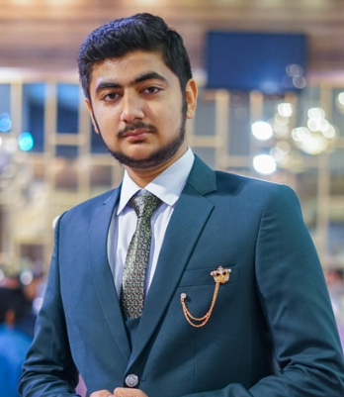 | ABDUL HASEEB QAZI  House No: R-118 Sharifabad,  F.B.Area, Block-1,  Karachi - Pakistan | CONTACT  Cell #: 0334-2102118  EMAIL  qaziabdulhaseeb82@gmail.com

Career Objective:

Innovative Web Developer seeking to leverage expertise in HTML, CSS, and JavaScript to contribute to creative and user-friendly web solutions.

Career Details:
As a versatile professional with a strong foundation in web development, graphic design, and web design, I have cultivated a diverse skill set that enables me to create visually compelling, user-friendly, and technically robust digital experiences. My career journey has been marked by a passion for blending aesthetics with functionality, ensuring that every project not only looks great but also performs optimally across all devices.

- Web-Development
- Web-Designing
- Graphics Designing
- UIUX Designing
- Logo Designing
- Ms-Office

Job Details :

No job.

Key Achievements:

As a versatile web developer, graphic designer, and web designer, I have consistently delivered high-impact results by developing optimized websites that boost user engagement, leading successful digital rebranding projects that enhance brand recognition, and earning industry awards for innovative, user-centric designs. My ability to combine technical expertise with creative design has contributed to increased traffic, improved user experiences, and measurable business growth.

EDUCATION:

ACADEMIC QUALIFICATION

- Bachelor of Computer Science 2023-2027 Sir Syed University B.S.C.S
- Higher Secondary School 2022 Govt Jinnah College H.S.C.
- Secondary School Certificate 2020 Happy Palace School S.S.C.

OTHER SKILLS

Aptech Computer Institute 1997
Web Development

- Roshi Computer Institute 1986
Graphic Designing

Roshi Computer institute Typing 2021
Typing Skills

- Excellent Command in MS Office Professional, Windows, Email & Internet

PERSONAL DETAILS

Marital Status : Unmarried
No of Dependents : 0
Date of Birth : June 29th 2004
Hobbies : Cricket & Badminton

References will be furnished upon request

